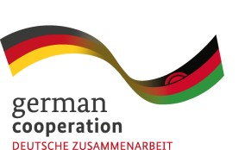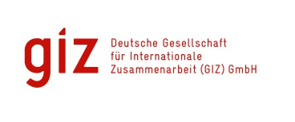
Implemented by:

Malawi: Strengthening public financial and economic management
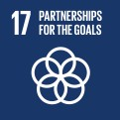
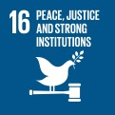
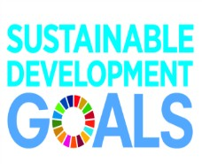
Supporting development financing by improving budget execution, contract management and tax administration

The challenge
Project name | Strengthening public financial and economic management
Commissioned by | Federal Ministry of Economic Cooperation and Development (BMZ)
Implementing organisation | Deutsche Gesellschaft für Internationale Zusammenarbeit (GIZ) GmbH
Project region | Malawi
Lead executing agency | Ministry of Finance, Economic Planning and Development
Duration | April 2022 – March 2025
Financial volume | € 4.5 Mio. EUR

Malawi is one of the poorest countries in the world. Half of the population lives below the national poverty line, measuring the cost of meeting nutritional and other basic needs (50,3 %; National Statistics Office, 2021). Poverty reduction in the country has stagnated over the last 15 years and has been negatively impacted by natural disasters and the economic impact of the COVID-19 pandemic.
Current government efforts to improve the livelihood of the Malawian people take place in a challenging macro-economic and fiscal context. This context is characterized by high inflation, increasing commodity prices, growing exchange rates pressures and unsustainable levels of public debt (IMF, 2021).
Achieving sustainable development in line with its long-term strategy "Malawi 2063” will require the Government of Malawi to more effectively raise its own revenues and to strengthen the management of public expenditures.

Our approach
The current “Strengthening Public Financial and Economic Management” project is implemented by German Agency for International Development Cooperation (GIZ) on behalf of the German Federal Ministry for Economic Cooperation and Development (BMZ). Over a period of three years (2022 –2025), it aims to promote key dimensions of good financial governance in Malawi: Efficiency, regularity, self-financing capacity and accountability. To this end, the project engages key stakeholders in the public finance system in Malawi on aspects of budget execution, the management of public contracts and tax administration. It provides technical, process and strategy advice and limited financial support, focusing on building individual and institutional capacity. It also places a focus on supporting the use of digital systems and on supporting change management.
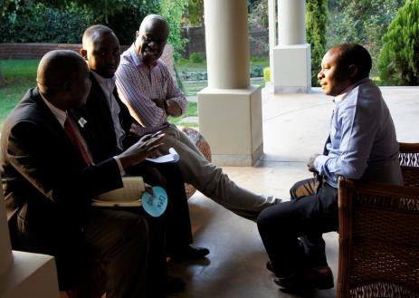

The lead executing agency of the project is the Ministry of Finance & Economic Affairs, which plays a key role in setting fiscal policy and in managing the public budget. Other key project partners are the Office of the President and the Malawi Revenue Authority. Sustainability is ensured through the involvement of internal administrative institutions such as the Malawi Institute of Management (MIM) and the Staff Development Institute (SDI), and the use of train-the-trainer concepts and on-the-job training.
Within the Ministry of Finance & Economic Affairs, the project focuses on working with the Accountant General’s Department. Support focuses on the technical requirements and qualifications needed for achieving the full functionality of the newly acquired Integrated Financial Management Information System (IFMIS). A functional IFMIS provides for a quick and centralized access to information on financial and economic performance, critically underpinning the orderly, efficient and transparent management of public finances. Key project activities include the provision of tailor-made trainings to IFMIS end-users in budgetary units (Ministries Departments and Agencies) and advice on risk management around IFMIS operations.

Left (top and bottom): Employees of different public finance institutions exchange ideas and challenges. Inter- institutional knowledge transfer, through regular meetings or electronic formats ensures more effective implementation of new processes and reforms. © GIZ Jan Dannheisig

Right: A government employee is supported using the Integrated Financial Management System (IFMIS), Malawi’s financial management system.

Photos: © GIZ

Photos: © GIZ
Contact person

Lukas Fischer
Team Leader
lukas.fischer@giz.de
Right: Malawian’s are highly dependent on Lake
Malawi for food and tourism. Intransparent contracts for oil exploration on the lake could endanger their livelihood. © Jan Dannheisig, Rachel Etter-Phoya

Support to the Malawi Revenue Authority (MRA) centers on strengthening capacity to audit transfer pricing arrangements of international firms. Through such audits, MRA ensures that multinational companies refrain from unduly shifting taxable profits out of Malawi to tax havens.
To this end, the project advises MRA on the application of relevant national and international tax legislation and on the corresponding organizational, technical and administrative requirements. Furthermore, MRA is advised on measures for the digitalization of tax administration and taxpayer education and outreach around the online tax administration system Msonkho Online. Building capacity in MRA to register taxpayers and to properly asses their tax liability supports the effective mobilization of tax revenues, helping the Government of Malawi to maintain the functioning of the state and ensure the financing of its development policies.

Results in figures ...
The current “Strengthening Public Financial and Economic Management” project is being implemented from April 2022 through March 2025. However, it builds on results achieved under two previous project commissions, with the latest running from 2018 to 2022. Over that period, the core modules of the new SAP IFMIS have successfully been rolled out and are currently being used by central government ministries, departments and agencies (MDA). More than 1,000 Government accounting officers received IFMIS-related trainings, benefitting from a training-of-trainers concept and the establishment of IFMIS training labs in Lilongwe (2) and Blantyre (1). Several government institutions (13) including regional hospitals in Blantyre, Zomba and Mzuzu have been connected to the IFMIS with the support of the project. All Government MDAs, except for Malawi Defense Force (MDF) and State Residence, process their transactions through IFMIS, thus making them faster and easier to track and audit. The 2022-23 budget was also prepared through the new SAP IFMIS eliminating some manual aspects of the budget preparation process (programme based budget). The project also provided Financing of ICT Infrastructure, supporting inter alia the establishment of an interface and linkages between the IFMIS and other IT systems (e.g. MRA, Reserve Bank of Malawi). Benefits include back-up connectivity in case of a disaster.

... and in stories
Additionally, support to Cash Management Unit (CMU) has seen great improvements in the Government’s cash management. A dedicated cash management unit has been established and weekly cash flow forecasts are now produced and utilized. The Government’s.bank accounts are being reconciled as a routine process, and the implementation of auto-bank reconciliation is in progress.
With a view to contract management, the previous project has assisted the Government Contracting Unit (GCU) in laying key foundations for the successive capacitation of all Government MDA. The development of a contract management training guide by GCU in close cooperation key Government entities responsible for staff development and training allowed for mainstreaming contract management knowledge in 8 MDAs. A systematic assessment of previous cases reviewed by GCU provides a strong basis for further improvements to contract management in the future.
Prior support on transfer pricing has centered on providing MRA auditors with hands-on guidance on how to identify high-risk cases and on managing audits. To this end, a practice note, an audit manual, and an orientation package were developed, as well as information materials for taxpayers. Hands-on training and mentoring around key topics identified by auditors has translated into increased confidence of MRA auditors in tackling transfer pricing issues. The example of a case settled with a tax yield of KWA 922m, plus interest of KWA 334m, shows that improved MRA capacities make it harder for foreign companies to avoid paying taxes in Malawi.
Beyond these areas of work, previous project commissions have additionally focused on strengthening key formal accountability actors, most notably the National Audit Office and the Central Internal Audit Unit within the Ministry of Finance & Economic Affairs. Important achievements relate to improved audit capacities on standard and special audit types, quality assurance and the development of critical IT infrastructure and systems. In addition, support to Civil Society Organizations, media and a multi-stakeholder platform to increase transparency in the management of natural resources (EITI) has contributed to strengthen the public in holding Government to account.
Published by: Deutsche Gesellschaft für
Internationale Zusammenarbeit (GIZ) GmbH
Registered office: Dag-Hammarskjöld-Weg 1–5
65760 Eschborn
Germany
T: +49 61 96 -11 475
Author: GIZ PFEM
Layout: GIZ
As at: May 2022
GIZ is responsible for the content of this publication.

In cooperation with: Ministry of Finance & Economic Affairs
On behalf of: German Federal Ministry for Economic Cooperation and Development (BMZ)
BMZ, Berlin
10963 Berlin,
Germany
T: +49 30 18 535-0
BMZ Bonn Dahlmannstraße 4
53113 Bonn, Germany
T: +49 0 228 99 535 – 0

poststelle@bmz.bund.de www.bmz.de

Addresses of the BMZ offices:
In Cooperation with: Ministry of Finance & Economic Affairs
2

