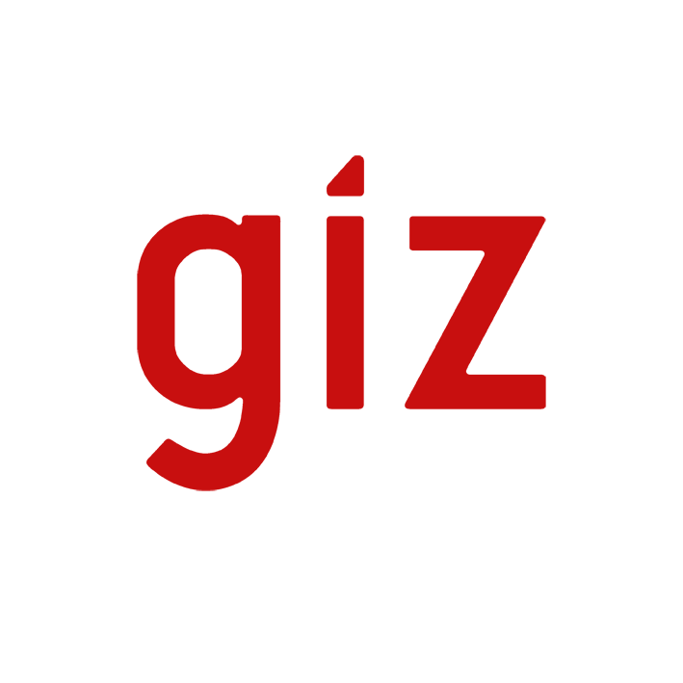streifen-s1

Presentation of the GIZ Company Report 2011

by the Chairman of the GIZ Management Board, Dr Bernd Eisenblätter,

at the annual press conference

on 26 June 2012 in Berlin, Federal Press Conference building

***Check against delivery.***

Good morning, ladies and gentlemen,

I am very pleased to welcome you here today, and I’m delighted that you have joined us to review last year and take a look at developments in 2012.

You see me here at my final press conference in my capacity as Chairman of GIZ’s Management Board. At the end of the month, in a few days’ time, I’ll be retiring from the company where I have worked for almost twenty years. I’ll be leaving behind a company that has refocused, has numerous commissioning parties and has just achieved an all-time record volume of business – two billion euros. And it has successfully completed a merger.

Today we are Germany’s leading service provider for international cooperation in industrialised, emerging and developing countries, where we work in a wide range of areas. Our activities continue to focus on sustainable results. This is what the German Government commissions us to do. And it is why businesses, the EU, the United Nations and many others are happy to use the services of our experts.

In 2011 our volume of business – which is the same thing as our total turnover – amounted to more than two billion euros (or to be precise: 2,032 million euros). This was more than ten **per cent** up on the 2010 figure. It marked a **new record** for GIZ, and was higher than forecast. Above all, though, it reflects the high esteem in which our services are held – the services we deliver to support sustainable solutions that promise a better future for millions of people.

At the same time it demonstrates the efficiency GIZ has already achieved in its first year, a year in which the company’s integration process without a doubt commanded a great deal of our time and attention. Though we have not yet reached the end of the process, we can already say one thing: the merger is paying off. Yes, we are now an even better service provider for the German Government. Yes, our expertise is in greater demand today than ever before – in industrialised countries (including Germany), in emerging economies and in developing countries. And yes, we have become more efficient. We intend to pursue the course for growth, with our workforce, as our ongoing activities demonstrate.

In Germany we now have a proven track record in bringing stakeholders together and developing effective solutions. The Bavarian State Ministry of the Environment and Public Health has commissioned GIZ to chair the Dialogue Forums on Green Hydropower in Bavaria. Bavaria has the target of meeting 17 per cent of its energy needs through hydropower by 2021. To achieve this, a broad social consensus will be needed. This will involve striking a balance between the various interests of municipalities, environmental organisations, citizens, hydropower companies and Bavarian ministries.

In North Rhine-Westphalia, the Bonn International Summer School on Responsible Business is about to start. At this event, supported by the Bonn-Rhine-Sieg University of Applied Sciences, the Centre for Development Research of the University of Bonn, the German Development Institute and Ernst & Young, international experts from all continents will be discussing issues vital to our future ranging from education to climate change, and furthering their learning.

Through our services, we achieve sustainable changes that are an investment in people’s future and at the same time we generate positive effects for Germany. To deliver these services, we believe in cooperating with the private sector. I needn’t mention the outcome of last week’s Rio + 20 Conference, at which the major challenges of our times were discussed: poverty and economic development, the over-exploitation of natural resources and climate change. But I would like to tell you about cooperation with the private sector, and about the sustainable results generated by good cooperation in the field of renewable energy. Our position on this is very clear.

Today, Brazil uses mostly renewable energy in the form of hydropower. Yet the country not only has a huge appetite for energy; it also has vast potential for solar power. How this potential can be leveraged has already been successfully demonstrated. This sunny Latin American country is now home to the first solar-powered football stadium, and the Brazilian Government has passed a national law concerning the feeding of electricity into the supply grid. This is the sustainable result of the advisory services delivered by our experts, on behalf of the Federal Ministry for Economic Cooperation and Development (BMZ). Incidentally, 75 per cent of the project funding was provided by our Brazilian partners, and 25 per cent of it by BMZ. The 60,000 euros spent on the GIZ advisory services thus triggered an investment of around 2.3 million euros. This means that for every euro of the German taxpayer’s money, almost 40 euros of Brazilian private-sector funds was mobilised for investment in renewable energy. The solar panels were built by a German-Brazilian joint venture involving the Bavarian company Gehrlicher Solar, which won the tender.

We also work together effectively with the German private sector, for instance with the insurer Allianz Re. In future, more than five million small farmers and their families in Asia will be able to insure themselves against financially ruinous crop losses. To achieve this, GIZ – acting on behalf of the Federal Ministry for Economic Cooperation and Development (BMZ) – and Allianz Re joined forces with the Swiss Agency for Development and Cooperation (SDC). State of the art satellite technology and new growth models are supplying data that allow harvest volumes to be accurately estimated. These estimates are then used as a basis to calculate the damage that would ensue in case of partial crop loss, and thus the amount that would be paid in compensation. Policies are being offered in seven Asian countries, enabling around 30 million people to take a first step toward greater financial security.

Many other German private-sector companies, including BASF [food enrichment], Daimler [training of mechatronic engineers in China] and TUI [inclusion of women in the tourism sector] are now turning to GIZ in the same way as Germany’s various federal ministries, individual countries such as Saudi Arabia [vocational training], the EU [election observation missions] and the Bill & Melinda Gates Foundation [cashew cultivation and processing]. GIZ has a wide range of commissioning parties. And they value our services highly. A look back at last year will illustrate this.

Our volume of business of 2 billion euros (or to be precise: 2,032 million euros) surpassed our planning targets.

In 2011 we once again operated chiefly on behalf of our main commissioning party, BMZ, from which we received 75 per cent of our business (worth around 1,533 million euros). Eleven per cent (223 million euros) was accounted for by other German federal ministries, with the largest share coming from the Federal Foreign Office (83 million euros), followed by the Federal Ministry for the Environment, Nature Conservation and Nuclear Safety (around 56 million euros) and the Federal Ministry of Defence (around 24 million euros).

Around a further 14 per cent (277 million euros) came from foreign governments and international organisations such as the EU and the UN. And even when we do operate on behalf of BMZ or another federal ministry, other organisations such as the Bill & Melinda Gates Foundation are often so impressed that they make a financial contribution. Just under a quarter of GIZ’s total volume – around 460 million euros – therefore does not come from the taxpayer’s pocket. These funds are provided by businesses, other countries or foundations [under cofinancing arrangements or in the form of contracts placed with International Services].

Behind these achievements are 17,185 staff (at 31 December 2011), 80 per cent of whom (13,816 staff) were employed abroad, and 20 per cent (3,241 staff) in Germany.

Yet they were not the only ones behind our achievements. A further 3,000 people worked for GIZ in 2011. These included just under 1,000 development advisors. Furthermore, the Centre for International Migration and Development (CIM), a joint operation of GIZ and the Federal Employment Agency, places experts with local employers. As 2011 drew to a close, almost 600 integrated experts were employed by local organisations and companies. Around 450 returning experts were receiving either financial assistance or advisory and other support services from CIM. And almost 500 young people were placed in partner countries in 2011 through the *weltwärts mit der GIZ* volunteer programme.

Successfully managing the merger and the refocusing process was not an easy task. Together we accomplished it, and I’m proud of this achievement of our staff.

And I would like to thank them for that. Everything I’ve told you about today is the product of their work. Their extensive expertise and huge commitment enabled us to achieve sustainable results that successfully fulfilled the expectations of our commissioning parties and changed many people’s lives for the better. 2011 was GIZ’s inaugural year, and no doubt we still need time to grow together as a company. But we have completed a very successful first year. That leaves me highly satisfied, and will make it just a little bit easier for me in a few days to say goodbye to GIZ, secure in the knowledge that it is very well placed for the future.

Many thanks!