Press release | 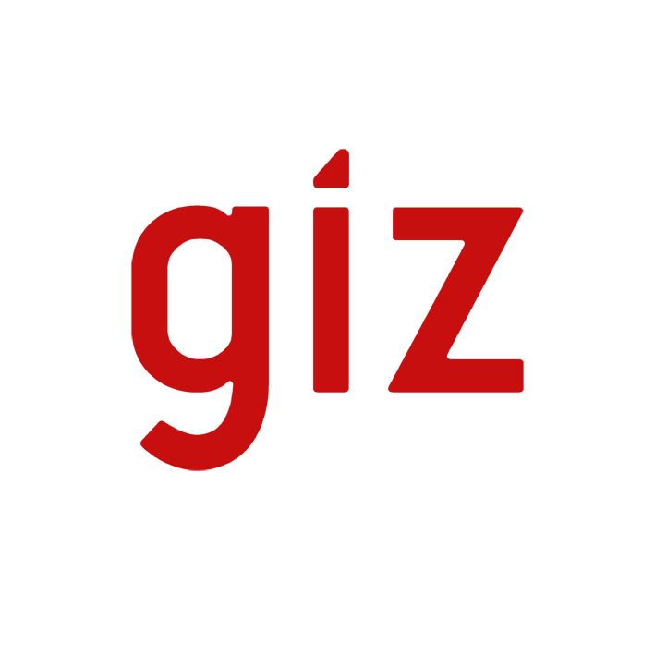

The merger is paying off  Working even more effectively and efficiently for the German Government – total turnover EUR 2 billion | 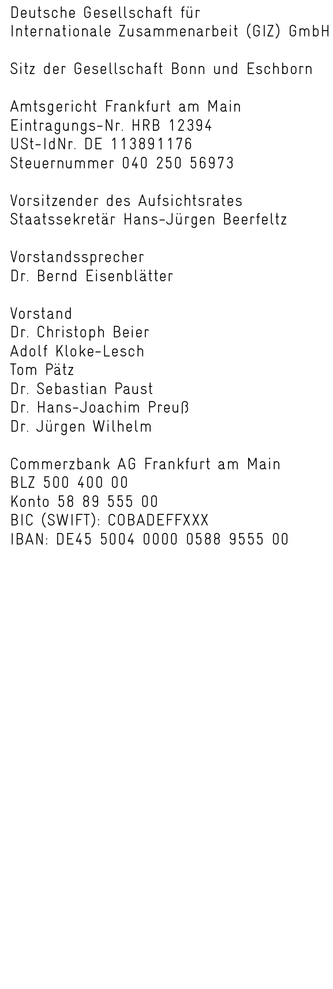  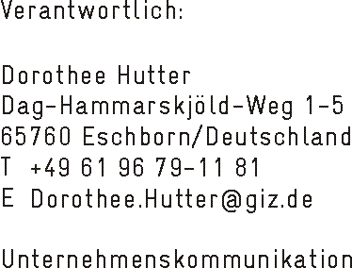  Editor:  Anja Tomic  T +49 61 96 79-4466  F +49 61 96 79-80 4466  E presse@giz.de
Berlin, 26 June 2012. At the annual press conference in Berlin, Bernd Eisenblätter, Chairman of GIZ’s Management Board, said how very satisfied he was with developments during GIZ’s inaugural year. ‘Last year, we went a long way toward successfully forging an effective and efficient company from three organisations’, said Eisenblätter. ‘The merger is paying off. And the high demand for the advisory services we deliver for the German Government confirms that we remain on course.’ In 2011 the company chalked up a record high, achieving a total volume of EUR 2 million – a year-on-year increase of ten per cent.
‘GIZ’s business results in 2011 show that the most important structural reform in German development cooperation has been a success. GIZ’s services are held in high regard throughout the globe. They are in demand, and are sought not just by BMZ, but also by other ministries, governments and international organisations. GIZ brings together the valuable experience and expertise of its predecessor organisations, thereby increasing the impact and effectiveness of development cooperation,’ said Hans-Jürgen Beerfeltz, State Secretary in the German Federal Ministry for Economic Cooperation and Development (BMZ) and Chair of the GIZ Supervisory Board.
In 2011 GIZ’s volume of business (or total turnover) reached a level of around EUR 2 billion (the precise amount was EUR 2,032 million), which was ten per cent higher than the previous year’s figure. This is a new record for GIZ, and reflects the high regard in which the company’s services are held.
In 2011 GIZ once again received most of its business (75 per cent, or commissions worth EUR 1,533 million) from BMZ. Eleven per cent was provided by other German federal ministries, with the largest share coming from the Federal Foreign Office (EUR 83 million), followed by the Federal Ministry for the Environment, Nature Conservation and Nuclear Safety (around EUR 56 million) and the Federal Ministry of Defence (around EUR 24 million). Around a further 14 per cent (EUR 277 million) came from foreign governments and international organisations such as the EU and the UN.
As at 31 December 2011, GIZ employed a total of 17,185 staff (compared to a figure of 17,296 as at 31 December 2010). Eighty per cent of these (13,816 staff) were employed abroad, and 20 per cent (3,241 staff) in Germany. A further 3,000 persons also worked for GIZ in 2011: just under 1,000 development advisors, almost 500 weltwärts volunteers and 1,050 integrated, returning and local experts.
The Deutsche Gesellschaft für Internationale Zusammenarbeit (GIZ) GmbH is a federal enterprise with worldwide operations. We support the German Government in the fields of international cooperation for sustainable development and international education. Through our work we assist people and societies in shaping their own futures and improving living conditions.

