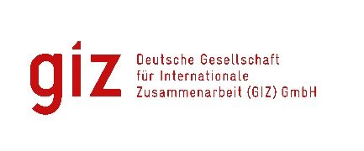
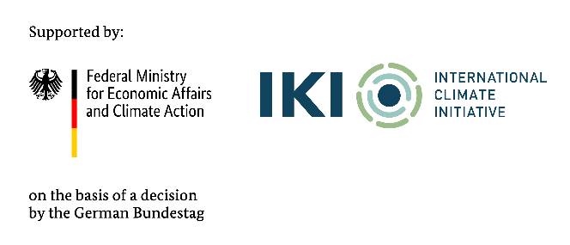

Calling for expression of interest
Research, assess, propose potential online platform for road freight transport in Vietnam to Improve Truck Load Factors
Tender code: 83492595

- Background
As a federally owned enterprise, the Deutsche Gesellschaft für Internationale Zusammenarbeit (GIZ) GmbH supports the German Government in achieving its objectives in the field of international cooperation for sustainable development. On behalf of the German Government, GIZ provides advisory services to the Vietnamese Government in four priority areas: (1) Vocational training, (2) Environmental, (3) Energy, and (4) Sustainable Economic Development. For further information, please visit www.giz.de/viet-nam.

Through the International Climate Initiative (IKI) GIZ has been commissioned by the German Federal Ministry of Economic Affairs and Climate Action (BMWK) with the implementation of the “Support to Vietnam for the Implementation of the Paris Agreement II” project (short: “SIPA II”) for a 5-year period from 2024 to 2029. The IKI is implemented by the BMWK in close cooperation with the Federal Ministry for the Environment, Nature Conservation, Nuclear Safety and Consumer Protection and the Federal Foreign Office.
The lead executing agency on the Vietnamese side is the Vietnamese side is the Ministry of Agriculture and Environment (MAE). The project aims to support Viet Nam’s development pathway and its consistency with a just net-zero transition in line with the Paris Agreement, the Convention on Biological Diversity, and the 2030 Agenda on Sustainable Development.
Vietnam’s economy has been growing rapidly, with significant contributions from the manufacturing and logistics sectors. The road freight market alone is projected to grow from USD 24.58 billion in 2024 to USD 35.83 billion by 2030. The logistics sector, particularly road freight, is a significant contributor to greenhouse gas emissions. As Vietnam continues to industrialise, the environmental footprint of logistics operations is becoming a critical concern. With a dominant transport market share in 05 transport sub-sectors, road transport stands out as the sub-sector responsible for the highest greenhouse gas emissions compared to the other 04 types of transport.
In response, the Vietnamese government has increasingly focused on sustainable development and carbon reduction, with initiatives to promote green logistics and transportation. The Ministry of Transport has actively reviewed and revised relevant legal documents and policies to promote the green transition of the road freight transport area. However, up to now, little guidance has been given to road freight and logistics enterprises on the benefits and solutions of enhancing road freight efficiency towards carbon neutrality. Therefore, technical support to raise awareness, enhance knowledge, develop capacity for enterprises and improve connections among road freight and logistics enterprises and relevant stakeholders in this area is necessary.
The GIZ Office Hanoi as the contracting party, on behalf of the SIPA II project, is conducting a local negotiated tender to look for qualified Local Consulting Firm (LCF) to implement the assignment.
Tentative duration: from 01 October 2025 until 30 April 2026
Place of assignment: in Vietnam

Milestones | Estimated expert-days for orientation | Expert team
Milestone 1: Detailed Work Plan | 14 | - Team leader (01 expert)  - Road Transport/Logistics (02 experts: North - South)  - Port & Intermodal Transport (02 expert: North - South)  - Research Specialist (01 expert)  - Government & Policy (01 expert)  - Assistant (01 expert)
Milestone 2: Study, Research, and Assessment Report on the Operations of Freight Exchange Platforms Currently and Previously Active in Vietnam | 46
Milestone 3: Research Plan and Interview Toolkit | 61
Milestone 4: Report on the Readiness of Freight Exchange Platforms from the Perspective of Road Freight Transport Operators | 99
Total | 220 | Expert team of up to 08 members

- Requirements for the LCF
- Commercial register entry
- Average annual turnover for the last three financial years
At least: 75.000 EUR
- Average number of employees and managers for the past three calendar years
At least: 08 persons
- Technical experience assessment is based on reference projects that were conducted by LCF with a minimum value of 25.000 EUR to satisfy the following:
- Having 6 years of experience in providing consultancy services and research
- Having at least 05 reference projects conducting surveys on climate change or environmental issues
- Having at least 03 reference projects in transport in Vietnam
- Requirements for eligibility documents
Interested LCFs are requested to prepare the following documents in English:
- Letter of interest (with Director’s or authorised person’s signature and company stamp).
- Audited financial reports of the last 03 years. Important/key information in the audited financial reports or in annual tax reports must be translated into English if documents are in Vietnamese.
- LCF profile and technical experience, incl. Business license (for firm) or Decision of establishment (for association); Tax code registration; organisational chart; consortium agreement and nomination of consortium leading firm (if at least 02 entities join the assignment); similar experience/copy of contracts related to this assignment.

- Method of bid submission
LCFs send Eligibility dossiers to VN_PoS_Quotation@giz.de before 5 PM (Hanoi time) on 04.08.2025 with email subject: “Tender 83492595-Eligibility dossier-Company name”.

For data protection and information security reason: In case the total volume of your bids is below 10 MB, you can attach them directly in the email sent to us. In case the total volume of your bids is above 10 MB, the files must be sent via GIZ filetransfer system. We will provide guidance for using our filetransfer. Links stated in documents and files sent via other applications/systems are not accepted.

Bids sent after the submission deadline and bids sent to wrong email address will be disqualified.

- Notes
- Interested LCFs send letter of interest and request for tender documents to Question-from-bidder-PoS-VN@giz.de before 21.07.2025.
- Interested LCFs send eligibility assessment related questions to Question-from-bidder-PoS-VN@giz.de before 28.07.2025.
- Only selected bidders will be invited to present technical and financial offers.
- For the exchange rate at the corresponding time, please go to https://commission.europa.eu/funding-tenders/procedures-guidelines-tenders/information-contractors-and-beneficiaries/exchange-rate-inforeuro_en

- IKI Complaint Mechanism
To ensure the compliance with social and environmental standards and for the lawful use of approved funding under IKI, the IKI Independent Complaint Mechanism (ICM) is installed to enable people who suffer (potential) negative social and/or environmental consequences from (IKI) projects, or who wish to report the improper use of funds, to voice their complaints anonymously. The objective of the ICM is to avert or minimise possible damage and initiate effective countermeasures. ICM is applied to all activities of VN-SIPA II as an IKI project.

Any person or group of persons, or community that has been or may be affected negatively by or experience reprisals in relation to the Project can file a complaint or authorise a representative to file and pursue the complaint on their behalf. More information or instruction on how to file a complaint is available at https://www.international-climate-initiative.com/PAGE396-1

GIZ is obliged to ensure the confidentiality of all submitted documents by bidders.

