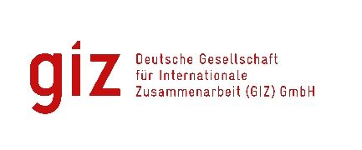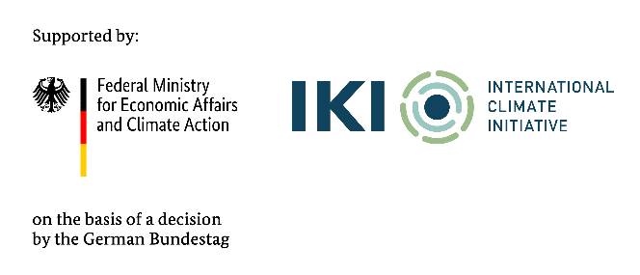

Calling for expression of interest
GHG Emission Analysis for Key Industrial Sectors under Decision 13/2024/QD-TTg Tender code: 83490374

- Background
As a federally owned enterprise, the Deutsche Gesellschaft für Internationale Zusammenarbeit (GIZ) GmbH supports the German Government in achieving its objectives in the field of international cooperation for sustainable development. On behalf of the German Government, GIZ provides advisory services to the Vietnamese Government in four priority areas: (1) Vocational training, (2) Environmental, (3) Energy, and (4) Sustainable Economic Development. For further information, please visit www.giz.de/viet-nam.

Through the International Climate Initiative (IKI) GIZ has been commissioned by the German Federal Ministry of Economic Affairs and Climate Action (BMWK) with the implementation of the “Support to Vietnam for the Implementation of the Paris Agreement II” project (short: “SIPA II”) for a 5-year period from 2024 to 2029. The IKI is implemented by the BMWK in close cooperation with the Federal Ministry for the Environment, Nature Conservation, Nuclear Safety and Consumer Protection and the Federal Foreign Office.

The lead executing agency on the Vietnamese side is the Vietnamese side is the Ministry of Agriculture and Environment (MAE). The project aims to support Viet Nam’s development pathway and its consistency with a just net-zero transition in line with the Paris Agreement, the Convention on Biological Diversity, and the 2030 Agenda on Sustainable Development.

To operationalise Viet Nam’s commitments under COP26 and prepare for a domestic carbon market, the Government has issued a series of guiding documents, including Decree No. 06/2022/ND-CP on GHG emissions mitigation and carbon market development. A revised version of this Decree is underway to provide detailed regulations for the Emissions Trading System (ETS), starting with three high-emitting sectors: power generation, cement (clinker), and steel (crude steel). These sectors—identified in Decision 13/2024/QD-TTg—account for approximately 70% of total GHG emissions from over 2,000 facilities nationwide. A critical next step for ETS readiness is the allocation of emission allowances to these compliance facilities.

This assignment aims to support that process by conducting a 2024 GHG emissions inventory for key industrial sectors—specifically crude steel manufacturing, coal and gas-fired power generation, and clinker-producing cement facilities—as listed in Decision 13/2024/QD-TTg. Covering at least 135 facilities (52 steel, 26 power, and 57 cement), the results will provide decision-makers with a comprehensive emissions profile of major emitters and inform the development of an effective emission allowance allocation approach for the ETS.

The GIZ Office Hanoi as the contracting party, on behalf of the SIPA II project, is conducting a local negotiated tender to look for qualified Local Consulting Firm (LCF) to implement the assignment.
Tentative duration: from 26 August 2025 until 31 December 2025
Place of assignment: in Vietnam
Milestones/  partial works | Estimated expert days  for  orientation | Expert team
Milestone 1: Detailed Work Plan | 24 | - Team leader and Climate Policy expert (01 expert)  - GHG Emission and Allocation Expert (01 expert)  - Industrial Process & Energy Expert – Iron and Steel Production (01-02 experts)  - Industrial Process & Energy Expert – Cement Production (01-02 experts)  - Energy Expert - Thermal Power Production (01-02 experts)  - Database development experts (01-02 experts)  Assistant (02-03 experts)
Milestone 2: Preliminary report on GHG Emissions Calculation Methodology and Data Stocktake | 218
Milestone 3: Final report on the GHG emission inventory of key industrial sectors | 373
Total | 615 | Expert team of up to 13 members

- Requirements for the LCF
- Commercial register entry
- Average annual turnover for the last three financial years
At least: 150.000 EUR
- Average number of employees and managers for the past three calendar years
At least: 10 persons
- Technical experience assessment is based on reference projects that were conducted by LCF with a minimum value of 50.000 EUR to satisfy the folowing:
- at least 3 reference projects in the technical field on:
- stakeholder consultations with governmental/private stakeholders in GHG inventory;
- complex consultations & stakeholder engagement with governmental/political partners in GHG emission policy.
- at least 3 reference projects with experience in similar assignments, especially national-level data collection, database development related to GHG in Viet Nam.

- Requirements for eligibility documents
Interested LCFs are requested to prepare the following documents in English:
- Letter of interest (with Director’s or authorised person’s signature and company stamp).
- Audited financial reports of the last 03 years. Important/key information in the audited financial reports or in annual tax reports must be translated into English if documents are in Vietnamese.
- LCF profile and technical experience, incl. Business license (for firm) or Decision of establishment (for association); Tax code registration; organisational chart; consortium agreement and nomination of consortium leading firm (if at least 02 entities join the assignment); similar experience/copy of contracts related to this assignment.

- Method of bid submission
LCFs send Eligibility dossiers to VN_PoS_Quotation@giz.de before 5 PM (Hanoi time) on 06.07.2025 with email subject: “Tender 83490374-Eligibility dossier-Company name”.

For data protection and information security reason: In case the total volume of your bids is below 10 MB, you can attach them directly in the email sent to us. In case the total volume of your bids is above 10 MB, the files must be sent via GIZ filetransfer system. We will provide guidance for using our filetransfer. Links stated in documents and files sent via other applications/systems are not accepted.

Bids sent after the submission deadline and bids sent to wrong email address will be disqualified.

- Notes
- Interested LCFs send letter of interest and request for tender documents to Question-from-bidder-PoS-VN@giz.de before 19.06.2025.
- Interested LCFs send eligibility assessment related questions to Question-from-bidder-PoS-VN@giz.de before 26.06.2025.
- Only selected bidders will be invited to present technical and financial offers.
- For the exchange rate at the corresponding time, please go to https://commission.europa.eu/funding-tenders/procedures-guidelines-tenders/information-contractors-and-beneficiaries/exchange-rate-inforeuro_en

- IKI Complaint Mechanism
To ensure the compliance with social and environmental standards and for the lawful use of approved funding under IKI, the IKI Independent Complaint Mechanism (ICM) is installed to enable people who suffer (potential) negative social and/or environmental consequences from (IKI) projects, or who wish to report the improper use of funds, to voice their complaints anonymously. The objective of the ICM is to avert or minimise possible damage and initiate effective countermeasures. ICM is applied to all activities of VN-SIPA II as an IKI project.

Any person or group of persons, or community that has been or may be affected negatively by or experience reprisals in relation to the Project can file a complaint or authorise a representative to file and pursue the complaint on their behalf. More information or instruction on how to file a complaint is available at https://www.international-climate-initiative.com/PAGE396-1

GIZ is obliged to ensure the confidentiality of all submitted documents by bidders.

