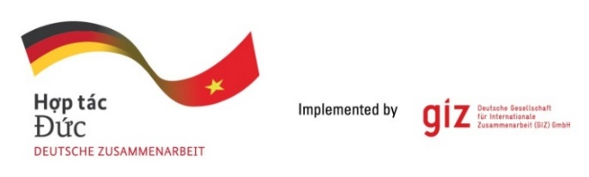

Calling for expression of interest
Tender package 83455916
Provision of local CONSULTANCY SERVICE
Assignment: Establishment of the local CIRCO Hub in Viet Nam

As a federally owned enterprise, Deutsche Gesellschaft für Internationale Zusammenarbeit (GIZ) GmbH supports the German Government in achieving its objectives in the field of international cooperation for sustainable development. On behalf of the German Government, GIZ provides advisory services to the Vietnamese Government in four priority areas: (1) Vocational training, (2) Environmental, (3) Energy, and (4) Sustainable Economic Development. For further information, please visit www.giz.de/viet-nam.

The global programme “Go Circular” is commissioned by the German Federal Ministry for Economic Cooperation and Development (BMZ) and implemented by the Deutsche Gesellschaft für Internationale Zusammenarbeit (GIZ). It aims to support the transition to a Circular Economy (CE) at global level and in the three partner countries: Colombia, Ghana and Viet Nam. Go Circular works in three priority areas: i) Promoting innovation, ii) Scaling up solutions and iii) Action in global alliances. The programme currently addresses the following key material flows: plastics, electrical and electronic equipment including batteries and organic waste as well as textiles. Cross-cutting themes pursued are climate and the CE including integration with Nationally Determined Contributions (NDCs) from the Paris Climate Agreement, digitalisation and the CE as well as financing the CE. In Viet Nam, the project works closely with the Ministry of Planning and Investment (MPI) and the Central Institute for Economic Management (CIEM) as key political partners. It aims to promote CE business models through private sector support and advice on relevant decrees and policy initiatives.

The programme aims to support companies to identify and implement circular economy approaches. While being trained on design tools, local companies shall be facilitated to start circular business by defining a circular proposition and implementing a roadmap. For this goal, a pool of trainers shall be developed/ trained and a local hub for the coordination of perennial training tracks shall be established. The CIRCO method was selected as stand-out methodology with readily available training material that has been successfully used in 12 countries and an extensive pool of certified trainers internationally. By building on an existing method, the programme wants to leverage/scale existing international experience and avoid duplication – while at the same time address the need for some level of contextualisation.

On behalf of the Go Circular programme, GIZ Office Hanoi is conducting a tender to seek qualified Local Consultancy company (here after called as LC) for the assignment:
- Tentative duration: from 20.02.2024 until 30.03.2025
- Place of assignment: Hanoi, Da Nang, Ho Chi Minh city and other provinces as required
- LC’s number of working days: up to 240
- Requirements: The LC shall establish a local CIRCO Hub coordinating and conducting six further CIRCO tracks (from the 3rd track to the 8th track) following the completion of the T2T programme. The LC is expected to have in-depth expertise, 03 years in in the field of Green/Circular Economy/Business development/design or innovation (with 02 related projects accomplished), more than 05 years in delivering training and consultancy for the private sector. Expert team of the LC will be composed of a Circo Hub Coordinator and a Communication cum Coordination Assistant.

Please send email to Question-from-bidder-PoS-VN@giz.de before 25.12.2023 to receive tender documents.

Interested LCs are requested to prepare the following documents in English:
- Letter of interest (with Director’s or authorised person’s signature and company stamp)
- LC profile (incl. Business license (for firm) or Decision of establishment (for association), Tax code registration, organisational chart, similar experience/copy of contracts related to Green/Circular Economy/Business development/design or innovation)
- Audited financial reports of the last 03 years. Important/key information in the audited financial reports or in annual tax reports must be translated into English if documents are in Vietnamese
- Consortium agreement and nomination of consortium leading firm (if at least 02 entities joint the assignment)

LCs send Eligibility dossiers to VN_PoS_Quotation@giz.de latest by 17:00 (Hanoi time) on 08.01.2024 with email subject: “Tender 83455916-Go Circular-Eligibility dossier”.

GIZ is obliged to ensure the confidentiality of all bidding documents submitted.

Important notes:
- Request of tender documents to be sent to Question-from-bidder-PoS-VN@giz.de before 25.12.2023.
- Eligibility assessment related questions to be sent to Question-from-bidder-PoS-VN@giz.de before 02.01.2024.
- Eligibility dossier to be sent to VN_PoS_Quotation@giz.de before 5 PM on 08.01.2024. Sending documents to wrong email address will lead to disqualification of the bidder.
- Only selected bidders will be invited to present technical and financial offers.

