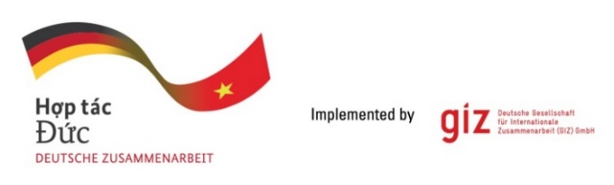

Calling for expression of interest
Tender package 83491399
Qualified consultant to perform language review and editing
in British-English language on publications, and content RELATED TO FORESTS

As a federally owned enterprise, Deutsche Gesellschaft für Internationale Zusammenarbeit (GIZ) GmbH supports the German Government in achieving its objectives in the field of international cooperation for sustainable development. On behalf of the German Government, GIZ provides advisory services to the Vietnamese Government in four priority areas: (1) Vocational training, (2) Environmental, (3) Energy, and (4) Sustainable Economic Development. For further information, please visit www.giz.de/viet-nam.

The project “Protection and Management of protected areas with diverse ecosystems in Viet Nam (MEPA)” implemented by GIZ together with the Department of Forestry and Forest Protection (FFP) under the Ministry of Agriculture and Envrionment (MAE) aims to enhance regulatory, institutional and technical capacities for implementing integrated management of protected areas jointly with the responsible authorities and the local population. The project is commissioned in October 2024 by the Federal Ministry for Economic Cooperation and Development (BMZ) with a duration from 01/2025 to 06/2028. Besides the national level, pilot activities will be implemented jointly with three protected areas (Van Long Nature Reserve in Ninh Binh province, Xuan Lien National Park in Thanh Hoa province and Hoang Lien National Park, Lao Cai province).

MEPA project shall focus: Improving the regulatory framework for an integrated management of protected areas in general and in three selected areas; Developing financing instruments; Progressing the approach for ecosystem restoration, as well as Advancing the approach for sustainable, community-based tourism.

On behalf of the MEPA project, the GIZ Office Hanoi is conducting an open tender without negotiation to seek qualified Individual Local Consultant (here after called as LC) for the assignment:
- Tentative duration: from August 2025 to June 2028
- Place of assignment: home-based
- Quantity: estimated pages would be 2305 pages in total
- Requirements: The selected consultant is expected to meet the following 3 Parts:

Part 1: British English proficiency
- Being a British English native speaker with a strong command of the British English language used in professional contexts; If the bidder is not British English native speaker, she/he must have evidence proving that they possess British English proficiency equal to a native speaker (for example IELTS – at least 8.0 overall and 8.0 for writing skills, TOEFL iBT – at least 110 overall and 28 writing skills, relevant linguistics certificate, etc).
- LCs have Work permit or Work permit exemption in Vietnam;
- LCs have Residence card in Vietnam;
- LCs have Bank account in Vietnam.

Part 2: Qualifications
- Bachelor’s degree in English language, media and communication, journalism, development studies or forestry;
- 07 years of experience proofreading and editing English usage products;
- 02 years of experience working for clients in the development cooperation sector from government offices, international NGOs, or international organisations;
- 02 years of experience proofreading and editing English usage of products on the topics of environment, forestry or biodiversity.

Part 3: Test exercises of approximately 86 pages of 350 words/page
Providing 3 high-quality samples of texts that were edited by the LCs with track changes, clearly showing your reviews and edits. The samples include:
- 01 social media post
- 01 technical report
- 01 policy brief

If you are interested in this tender, please send email to Question-from-bidder-PoS-VN@giz.de before 07.07.2025 to receive tender documents.

Interested LCs are requested to prepare the following documents in English:
- Technical proposal:
- Your CVs and other required relevant documents/certificates.
- Edited 03 texts with track changes for provided test exercises.

- Financial proposal: Calculate your financial bid exactly in line with the Quantitative requirements specified in the TOR.

Cost of preparing the bid: No remuneration will be granted for the preparation of the bid and the documents to be attached thereto.

GIZ is obliged to ensure the confidentiality of all bidding documents submitted.

Important notes:
- Request of tender documents to be sent to Question-from-bidder-PoS-VN@giz.de before 07.07.2025.
- Related questions to be sent to Question-from-bidder-PoS-VN@giz.de before 11.07.2025.
- Bid documents to be sent to VN_PoS_Quotation@giz.de before 5 PM on 22.07.2025. When submitting bidding documents for this tender, the bidder declares that she/he has read, understood, accepted and agreed with all information and conditions listed in the provided tender dossier.
- Sending documents to wrong email address will lead to disqualification of the LCs.
- For data protection and information security reason: In case the total volume of your bids is below 10 MB, you can attach them directly in the email sent to us. In case the total volume of your bids is above 10 MB, the files must be sent via GIZ filetransfer system. Guidance on how to use filetransfer will be provided. Files sent via other applications/systems such as Google drive, dropbox…will not be accepted.

