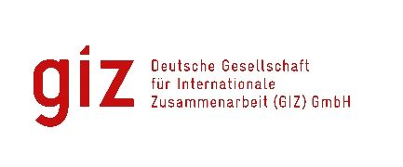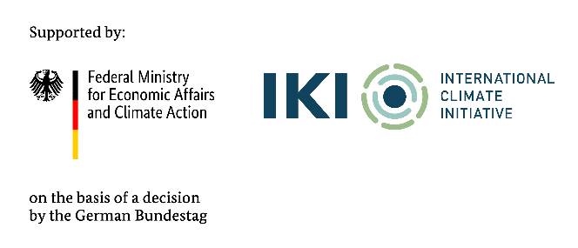
Call for expressions of interest (EoI)
Tender package NO. 83488493
Provision of local CONSULTANCY SERVICEs
Assignment: Technical SUPPORT FOR THE NDC 3.0 for the AFOLU Sector in the Period 2025-2035

- Background
As a federally owned enterprise, Deutsche Gesellschaft für Internationale Zusammenarbeit (GIZ) GmbH supports the German Government in achieving its objectives in the field of international cooperation for sustainable development. On behalf of the German Government, GIZ provides advisory services to the Vietnamese Government in four priority areas: (1) Vocational training, (2) Environmental, (3) Energy, and (4) Sustainable Economic Development. For further information, please visit www.giz.de/viet-nam.
Through the International Climate Initiative (IKI), GIZ has been commissioned by the German Federal Ministry for Economic Affairs and Climate Action (BMWK) with the project “Support to Viet Nam for the Implementation of the Paris Agreement II” (VN-SIPA II). The project supports Viet Nam’s development pathway toward a just, net-zero transition in line with the Paris Agreement (PA), and contributes to the implementation of the Convention on Biological Diversity (CBD) and the 2030 Agenda on Sustainable Development.
In the context of the development of Viet Nam’s NDC 3.0, the project provides technical analysis and support among others for the Agriculture, Forestry and Land Use and Land-use change (AFOLU) sectoral report.
On behalf of the “Support to Viet Nam for the Implementation of the Paris Agreement II” (VN-SIPA II) project, the GIZ Office Hanoi is conducting an open tender (without negotiation) to invite qualified National Consulting Firm(s) (hereinafter referred to as 'NC') to undertake the following assignment:
- Objective of assignment: Provide inputs on the Agriculture, Land-Use, Land-Use Change, Forest (AFOLU) sector reports for the NDC development in line with the requirements of Viet Nam’s Net Zero Commitment. Develop technical reports for the AFOLU sector in the NDC and collect and process relevant data to develop potential mitigation measures and scenarios including modelling, planning for the implementation of GHG emission reduction measures and propose examples for the detailed formulation of the measures and their monitoring, reporting and verification.
- Tentative duration: From July – 31st October 2025
- Place of assignment: Ha Noi, Viet Nam
- NC’s number of working days: Up to 502 days
- Requirements: The Contractor shall demonstrate that as a company, they fulfil the following requirements:
  - Compliance with legal requirements (e.g. commercial and tax registration, relevant licences etc)
  - Technical experience in forestry sector policy, climate change mitigation / deforestation in the forestry sector, forest monitoring and forest change tracking and conducting surveys, data analysis and modelling (at least 03 reference projects / assignments)
  - Experience of development projects (ODA-financed)
  - Well-acquainted with governmental and non-governmental stakeholders
- Requirements for eligibility documents
- Letter of interest (with Director’s or authorised person’s signature and company stamp).
- NC profile (incl. Business license (for firm) or Decision of establishment (for association), Tax code registration, organisational chart, similar experience/copy of contracts related to this assignment).
- Audited financial reports of the last 03 years. Important/key information in the audited financial reports or in annual tax reports must be translated into English if documents are in Vietnamese.
- Consortium agreement and nomination of the lead firm (required if two or more entities jointly undertake the assignment)

- Method of bid submission
If you are interested in this tender, please send an email to Question-from-bidder-PoS-VN@giz.de to receive tender documents before 06.06.2025.
After receiving tender documents, you are requested to submit as instructed below:
- Eligibility documents will be sent to VN_PoS_Quotation@giz.de with email’s subject “Tender 83488493 - Eligibility dossier-Company profile” latest by 17:00 (Hanoi time) on 20 June 2025.
- Technical proposal will be sent to VN_PoS_Quotation@giz.de with email’s subject “Tender 83488493 - Technical proposal” latest by 17:00 (Hanoi time) on 20 June 2025.
- Financial proposal will be sent to VN_PoS_Quotation@giz.de with email’s subject “Tender 83488493 - Financial proposal” latest by 17:00 (Hanoi time) on 20 June 2025.
Important notes:
- Questions related to eligibility assessment and proposal assessment to be sent to Question-from-bidder-PoS-VN@giz.de before 13 June 2025.
- Sending the eligibility documents, technical proposal and financial proposal in a separate email with a specific email’s subject as mentioned above.
- Financial proposal: Calculate your financial file exactly in line with the quantitative requirements specified in the TOR.
- No remuneration will be granted for the preparation of the bid and the documents to be attached thereto.
- Sending documents to the wrong email address will result in the disqualification of the bidder.
- For data protection and information security reason: In case the total volume of your bids is below 10 MB, you can attach them directly in the email sent to us. In case the total volume of your bids is above 10 MB, the files must be sent via GIZ file transfer system. We will provide the guidance on how to use file transfer to interested bidders. Files sent via other applications/systems such as google drive, dropbox…will not be accepted.
- GIZ is obliged to ensure the confidentiality of all bidding documents submitted.

IKI Complaint Mechanism
To ensure the compliance with social and environmental standards and for the lawful use of approved funding under IKI, the IKI Independent Complaint Mechanism (ICM) is installed to enable people who suffer (potential) negative social and/or environmental consequences from (IKI) projects, or who wish to report the improper use of funds, to voice their complaints anonymously. The objective of the ICM is to avert or minimise possible damage and initiate effective countermeasures. ICM is applied to all activities of VN-SIPA II as an IKI project.
Any person or group of persons, or community that has been or may be affected negatively by or experience reprisals in relation to the Project can file a complaint or authorise a representative to file and pursue the complaint on their behalf. More information or instruction on how to file a complaint is available at https://www.international-climate-initiative.com/PAGE396-1

