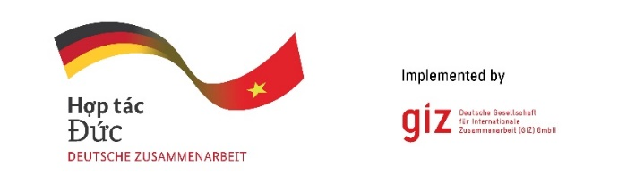

Calling for expression of interest

Analyse roles of offshore wind and LNG thermal power in power generation for
load-center in the northern and north central area until 2035
Tender code: 83498418

- Background
As a federally owned enterprise, the Deutsche Gesellschaft für Internationale Zusammenarbeit (GIZ) GmbH supports the German Government in achieving its objectives in the field of international cooperation for sustainable development. On behalf of the German Government, GIZ provides advisory services to the Vietnamese Government in four priority areas: (1) Vocational training, (2) Environmental, (3) Energy, and (4) Sustainable Economic Development. For further information, please visit www.giz.de/viet-nam.

The project “Promoting the transition of the energy sector in Viet Nam” (TEV) funded by German Federal Ministry for Economic Cooperation and Development (BMZ), to foster the development of a long-term political energy transition strategy, including legal and regulatory fundamentals, as well as the transfer of technological knowledge to MOIT (i.e., ERAV and EREA).

As part of the 2025 operational plan, the TEV project will engage a qualified local consulting firm to assess the roles of offshore wind and LNG-fired thermal power in meeting electricity demand in Northern and North Central Vietnam. These technologies are prioritised under the revised PDP8 but face significant implementation challenges. The study will evaluate their feasibility by 2030 (with a vision to 2035), analyse their technical, economic, and environmental implications, and propose alternative solutions if deployment falls short. It will also assess alignment with Vietnam’s energy transition and carbon neutrality goals, offering recommendations to optimise the regional power mix and address development bottlenecks.

The GIZ Office Hanoi as the contracting party, on behalf of the TEV project, is conducting a local negotiated tender to look for qualified Local Consulting Firm (LCF) to implement the assignment.
Tentative duration: from 01.11.2025 until 31.03.2026
Place of assignment: in Vietnam
Estimate working days: up to 180 working days for an expert team of 3 members

- Requirements for the LCF
- Commercial eligibility assessment:
- Commercial register entry
- In case of tenderer consortium: Declaration by tenderer consortium
- Average annual turnover for the last three financial years of at least: 40.000 EUR
- Average number of employees and managers for the past three calendar years of at least: 5 persons

- Technical eligibility assessment is based on reference projects or contracts that were conducted by LCF with a minimum value of 10.000 EUR to satisfy the folowing:
- Having operated 03 years in energy sector in Vietnam
- Having experienced providing the consulting services for at least 1 project in Vietnam on power planning in last 05 years (September 2020 - September 2025)
- Having experienced with at least 1 Development Cooperation project

- Requirements for eligibility documents
Interested LCFs are requested to prepare the following documents in English:
- Letter of interest (with Director’s or authorised person’s signature and company stamp)
- Audited financial reports of the last 03 years. Important/key information in the audited financial reports or in annual tax reports must be translated into English if documents are in Vietnamese

- LCF profile incl. Business license (for firm) or Decision of establishment (for association); Tax code registration; organisational chart; consortium agreement and nomination of consortium leading firm (if at least 02 entities join the assignment)
- Copy of reference projects or other documents to prove that LCF can meet all technical eligibility requirements mentioned in Section 2 above.

- Method of bid submission
LCFs send Eligibility dossiers to VN_PoS_Quotation@giz.de before 5 PM (Hanoi time) on 01.10.2025 with email subject: “Tender 83498418-Eligibility dossier-Company name”.

For data protection and information security reason: In case the total volume of your bids is below 10 MB, you can attach them directly in the email sent to us. In case the total volume of your bids is above 10 MB, the files must be sent via GIZ filetransfer system. We will provide guidance for using our filetransfer. Links stated in documents and files sent via other applications/systems are not accepted.

Bids sent after the submission deadline and bids sent to wrong email address will be disqualified.

- Notes
- Interested LCFs send letter of interest and request for tender documents to Question-from-bidder-PoS-VN@giz.de before 23.09.2025.
- Interested LCFs send eligibility assessment related questions to Question-from-bidder-PoS-VN@giz.de before 26.09.2025.
- Only selected bidders will be invited to present technical and financial offers.
- For the exchange rate at the corresponding time, please go to https://commission.europa.eu/funding-tenders/procedures-guidelines-tenders/information-contractors-and-beneficiaries/exchange-rate-inforeuro_en
- No remuneration will be granted for preparation of the submitted eligibility documents.

GIZ is obliged to ensure the confidentiality of all submitted documents by bidders.

