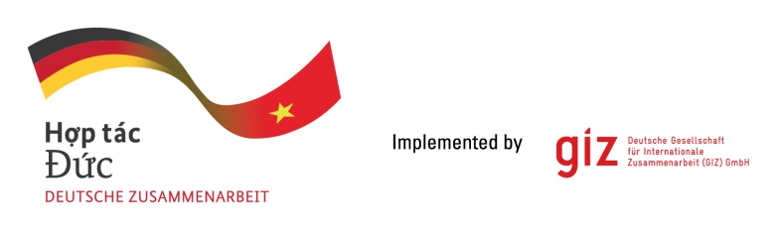

Calling for expression of interest (EoI)
TENDER PACKAGE 83505396
Provision of local CONSULTANCY
Assessment of the Potential of Artificial Intelligence and Digital Applications to Advance Energy Transition in Viet Nam’s Power Sector (phase 2)

- Background
As a federally owned enterprise, Deutsche Gesellschaft für Internationale Zusammenarbeit (GIZ) GmbH supports the German Government in achieving its objectives in the field of international cooperation for sustainable development. On behalf of the German Government, GIZ provides advisory services to the Vietnamese Government in four priority areas: (1) Vocational training, (2) Environmental, (3) Energy, and (4) Sustainable Economic Development. For further information, please visit www.giz.de/viet-nam.
The project “Promoting the transition of the energy sector in Viet Nam” (TEV) funded by German Federal Ministry for Economic Cooperation and Development (BMZ), to foster the development of a long-term political energy transition strategy, including legal and regulatory fundamentals, as well as the transfer of technological knowledge to EAV/MOIT.
The TEV project will engage a local consulting firm or organization to conduct a comprehensive study assessing assess the potential of AI and digital application in supporting in Viet Nam’s energy transition and the development of internationally competitive, low-carbon digital infrastructure. This assignment aims to harness both the best global practices and local insights to develop actionable recommendations that align with government’s targets and the collaborative spirit of JETP. Building upon the assessment and recommendations from Phase 1, this phase will refine the list of digitalization and AI application proposals for the power system, based on feedback regarding suitability from the Electricity Authority of Vietnam (EAV). It will also conduct a detailed assessment of readiness levels and transformation requirements for implementation, while developing a detailed roadmap for execution.
Therefore, GIZ Hanoi Office as the contracting party, on behalf of TEV project, is conducting a local negotiated tender to look for qualified Local Consulting Firm (here after called as LCF) to implement the assignment:
- Tentative timeframe of the assignment: from 06 February 2026 until 31 May 2026
- Place of Assignment: Viet Nam
- Estimate working days: up to 120 working days for the expert team of 03 members
- Requirement for the LCF
- Commercial eligibility assessment:
- Evidence of commercial register entry
- In case of tenderer consortium: Declaration by tenderer consortium
- Average annual turnover for the last three financial years (2022-2024) of at least: 50.000 EUR
- Average number of employees and managers for the past three calendar years of at least: 5 persons

- Technical eligibility assessment
The eligibility assessment is based on reference projects or contracts that were conducted by LCF with a minimum value of 10.000 EUR to satisfy the folowing:
- Having operated 05 years in Vietnam energy sector
- Having experienced providing the consulting services for at least 1 project in Vietnam Energy Policy/Technology Application/Digitalization for power sector in last 5 years (November 2020 - November 2025)
- Having experienced of at least one Development Cooperation project

- Requirements for eligibility documents
Interested LCFs are requested to prepare the following documents in English:
- Letter of interest (with Director’s or authorised person’s signature and company stamp)
- Audited financial reports and/or annual tax report accepted by tax authorities of the last 03 years (2022-2024). Important/key information in the audited financial reports or in annual tax reports must be translated into English if documents are in Vietnamese
- LCF profile incl. Business license (for firm) or Decision of establishment (for association); Tax code registration; organisational chart; consortium agreement and nomination of consortium leading firm (if at least 02 entities join the assignment)
- Copy of reference projects or other documents to prove that LCF can meet all technical eligibility requirements mentioned in Section 2 above.

- Method of bid submission
- LCFs send Eligibility dossiers to VN_PoS_Quotation@giz.de before 5 PM (Hanoi time) on 26.12.2025 with email subject: “Tender 83505396-Eligibility dossier-Company name”.
- For data protection and information security reason: In case the total volume of your bids is below 10 MB, you can attach them directly in the email sent to us. In case the total volume of your bids is above 10 MB, the files must be sent via GIZ filetransfer system. We will provide guidance for using our filetransfer. Links stated in documents and files sent via other applications/systems are not accepted.
- Bids sent after the submission deadline and bids sent to wrong email address will be disqualified.

- Important notes
- Interested LCFs send letter of interest and request for tender documents to Question-from-bidder-PoS-VN@giz.de before 18.12.2025.
- Interested LCFs send eligibility assessment related questions to Question-from-bidder-PoS-VN@giz.de before 21.12.2025.
- Only selected bidders will be contacted to present technical and financial offers.
- No remuneration will be granted for preparation of the submitted eligibility documents.

GIZ is obliged to ensure the confidentiality of all submitted documents by bidder(s)
during the tender process!

